1、Understand the app, what exactly the app is doing.
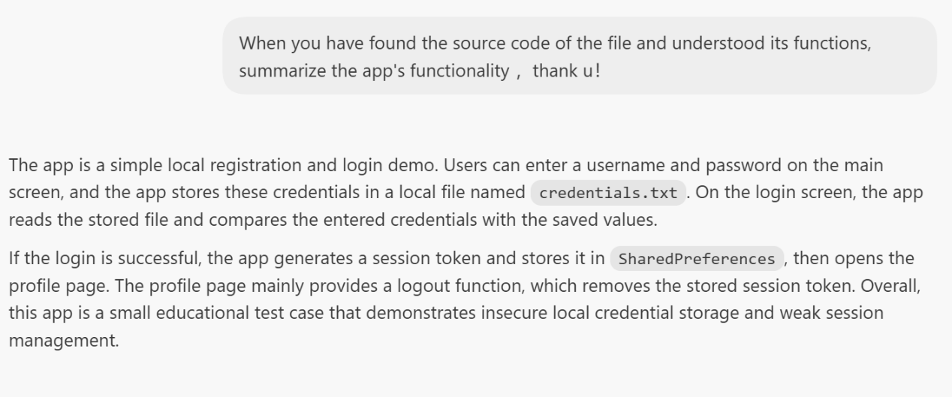
2、Draw a system model for better understanding how the app works.
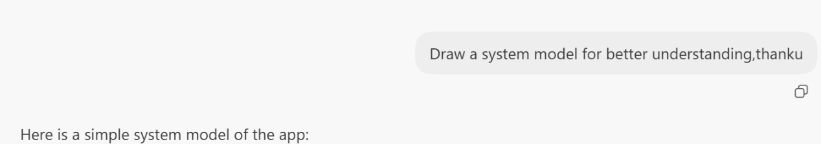
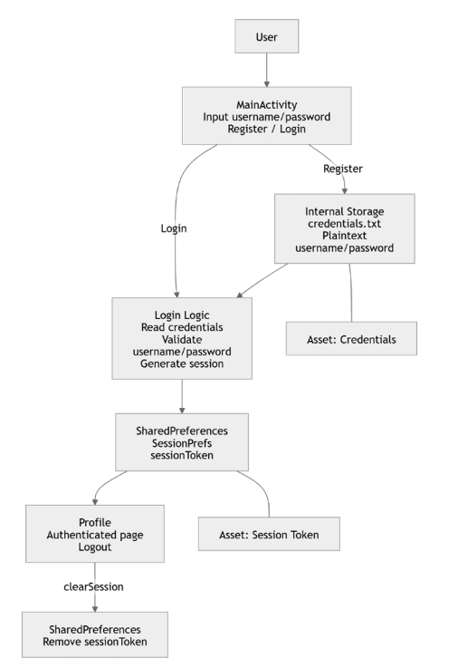
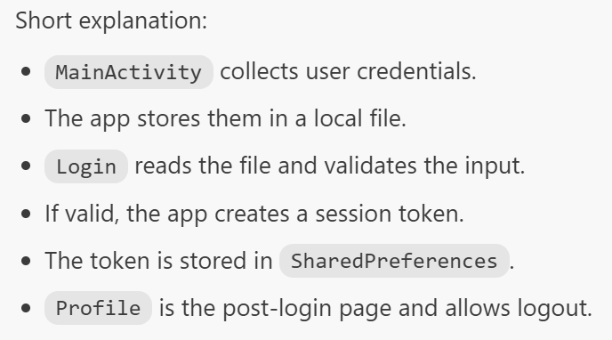
3、Ask codex for finding the most important and serious vulnerabilities
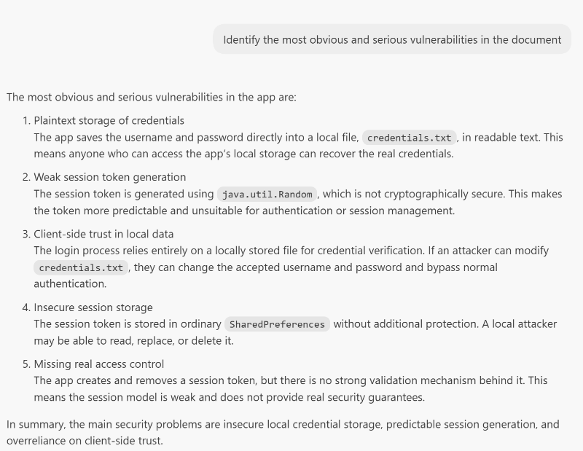
4、What can I do when facing that problems, how to fix that.
